Unit 2 Grade 10 Applied
Trigonometry

Lesson Outline

BIG PICTURE

Students will:
- investigate the relationships involved in right-angled triangles to the primary trigonometric ratios, connecting the ratios to constants of proportionality between similar triangles developed in Unit 1;
- solve problems involving right-angled triangles, using the primary trigonometric ratios and the Pythagorean theorem, including problems that require using imperial and metric measurements.
Day | Lesson Title | Math Learning Goals | Expectations
1 | What’s My Ratio? | - Determine sine, cosine, and tangent ratios for right-angled triangles using concrete materials. | MT2.01  CGE 3b
2 | What’s My Ratio? The Sequel | - Investigate the three primary trigonometric ratios for right-angled triangles.  - Summarize investigations. | MT2.01  CGE 5a, 5e
3 | What’s My Angle? | - Consolidate investigations for sine, cosine, and tangent ratios of right-angled triangles.  - Determine angles given trigonometric ratios, using scientific calculators.  - Research a career that requires the use of trigonometry. | MT2.01, MT2.04  CGE 3e, 7b, 7f
4 | Figure Out the Triangle | - Determine the measures of the sides and angles of right-angled triangles using the primary trigonometric ratios and the Pythagorean theorem. | MT2.01, MT2.02  MT2.04  CGE 4f, CGE 5a
5 | Solving Right-Angled Triangles  (Part 1) | - Determine the measures of the sides and angles in right-angled triangles, using the primary trigonometric ratios and the Pythagorean theorem. | MT2.02, MT2.03  CGE 3f
6 | Solving Right-Angled Triangles  (Part 2) | - Students make and use clinometers to measure angles.  - Determine the measures of inaccessible objects around the school using the primary trigonometric ratios and clinometers. | MT2.03  CGE 3c
7 | Trigonometric Applications | - Solve problems involving the measures of sides and angles in surveying and navigation problems. | MT2.03,  CGE 5b, 7b
8 | Who Uses Trigonometry?  (Project Presentations) | - Make a presentation to the class on careers that involve trigonometry. | MT2.04  CGE 2a, 2d
9 | Summative Assessment | Note: A summative performance task is available from the members only section of the OAME web site www.oame.on.ca
10 | Jazz Day

Unit 2: Day 1: What’s My Ratio? |  |  |  | Grade 10 Applied
  75 min |  | Math Learning Goals  - Determine sine, cosine, and tangent ratios for right-angled triangles using concrete materials. |  | Materials  - BLM 2.1.1, 2.1.2, 2.13  - string  - protractors  - ribbon  - clothespins
Assessment
Opportunities
 | Minds On… | Groups of 4 → Review  Distribute a right-angled triangle cut-out to each student (BLM 2.1.1). Students find the other three students with similar right-angled triangles to form their working group for the day.  Students use protractors and rulers to confirm if the corresponding angles are equal or sides are equal/proportional.  Reinforce that congruent figures are similar but similar figures are not necessarily congruent. Identify the presence of complementary angles in each of their triangles. |  | There is one congruent pair in each set of four similar triangles.  Record the letter names of triangles that go together so groups can be verified before activity.  Word Wall  - complementary angles  - opposite side  - adjacent side  - hypotenuse  Use a ribbon to mark the student who represents the reference angle.  See Mathematical Processes in Leading Math Success library
 | Action! | Whole Class → Demonstration  Identify the opposite, adjacent sides, and hypotenuse of a right-angled triangle with respect to a given angle. Connect to previous learning where students examined corresponding side measurements of two similar triangles. Explain that they are to explore the ratios within one right-angled triangle and the information that investigation might yield.  Form right-angled triangles using string for sides and three students as vertices of each right-angled triangle. Demonstrate using signs and clothespins, how the opposite and adjacent sides interchange depending on which angle is referenced. Work from inside the triangle. Students holding the sign stand at the reference angle and then walk to the opposite or adjacent sides and the hypotenuse.  Working in groups of four, students measure the lengths of the sides of their triangle and fill in column 1 on BLM 2.1.2. Then they fill in the next four columns of their chart.  Individually, students complete BLM 2.1.3 and share their answers.  Math Process/Reflecting/Oral Question: Assess how students reflect on the results of the activity by asking an appropriate question.  Whole Class → Instruction  Introduce terminology of sine, cosine, and tangent to define each ratio and as a convenient way of referencing the ratios. Students place these terms above the appropriate columns in BLM 2.1.2.
 | Consolidate Debrief | Whole Class → Demonstration  Repeat the string demonstration, asking which sides would be needed to represent the sine, cosine, and tangent ratios as a way of checking students’ responses to BLM 2.1.2.
Concept Practice |  | Home Activity or Further Classroom Consolidation  Construct a right-angled triangle that has angle measures different from your group of similar triangles. Measure the lengths of the sides of the triangle in both imperial and metric units. Determine the sine, cosine, and tangent ratios for your triangle. |  | Assign triangles with different angles, e.g., 42°, 48°, 90°.

2.1.1: Similar Triangles Template (Teacher)

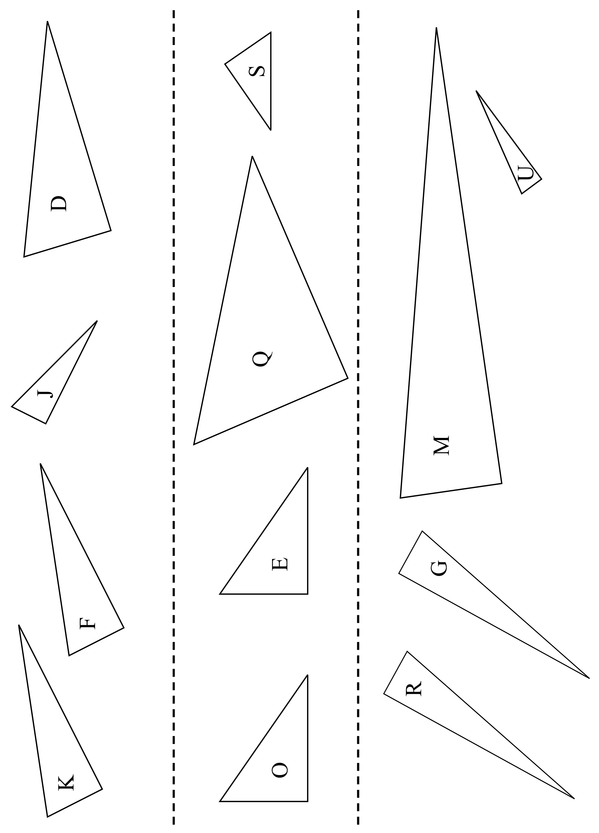
2.1.1: Similar Triangles Template (Teacher) (continued)

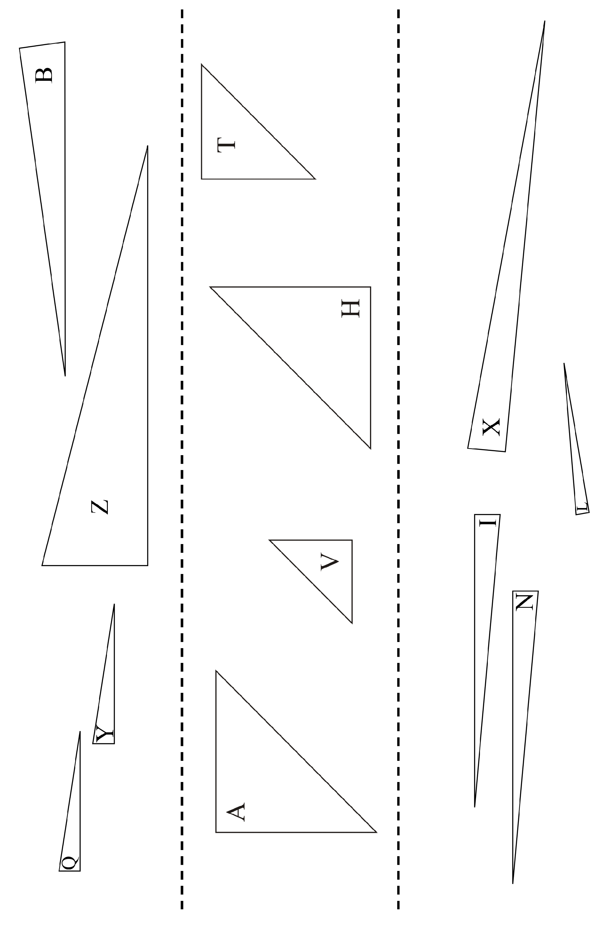
2.1.2: What’s My Ratio? Group Activity

Fill in each of the columns with information for your triangle.
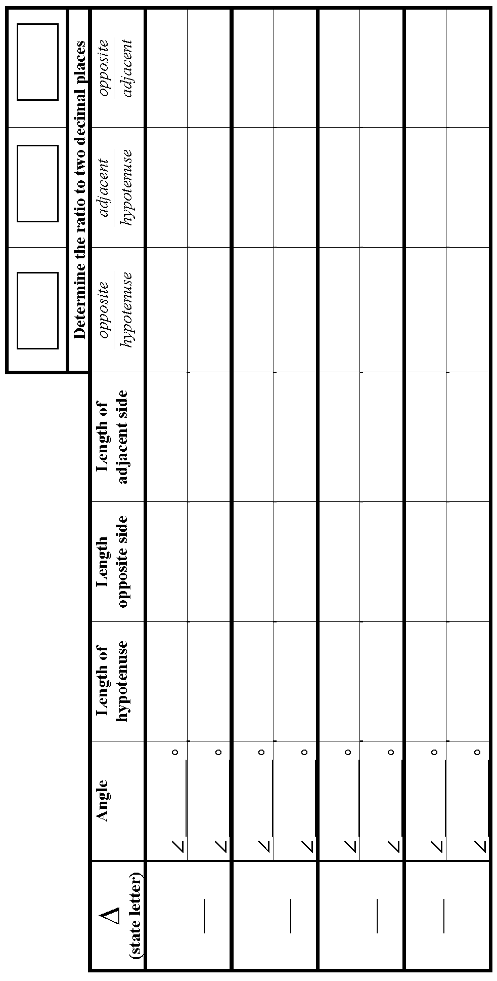
2.1.3: What’s My Ratio? Individual Reflection

1. If you have a fifth triangle that is similar to your four triangles, what would your hypothesis be about the following ratios? Explain.
Explanation: | Explanation: | Explanation:

2. Identify a relationship between the ratios in the chart for:
and

3. Identify a relationship if you divide the ratio for by
for one of the angles.

Unit 2: Day 2: What’s My Ratio? The Sequel |  |  |  | Grade 10 Applied
  75 min |  | Math Learning Goals  - Investigate the three primary trigonometric ratios for right-angled triangles.  - Summarize investigations. |  | Materials  - large chart (grid) paper  - 3 colours of stickers
Assessment
Opportunities
 | Minds On… | Groups of 4 → Activity  Students transfer information from the final three columns of BLM 2.1.2 onto the appropriate large grid paper, labelled Sine, Cosine, and Tangent. They use stickers of three different colours, one for each ratio.  Note: Developing the graph is used to represent the data collected and provides an example of a non-linear and non-quadratic relation. |  | Set up one large grid for each of the three ratios to graph results of the whole class.  Horizontal axis – degrees from  0 to 90  Vertical axis –  ratios from 0 to 1 in increments of 0.1
 | Action! | Whole Class → Discussion  Ask: What do you think the ratio for the sine of 42 degrees is?  Students write individual responses using the graph.  Demonstrate how to obtain the sine, cosine, and tangent ratio using the scientific calculator. Practise with various ratios and angles.  Individual → Activity  Students check answers from the Day 1 Home Activity using a calculator. Using stickers, students add more data points to the three large grids.  Math Process/Using Tools/Observation/Mental Note: Observe how students use their calculator to find sine, cosine, and tangent of angles.
 | Consolidate Debrief | Whole Class → Discussion  Use the three large classroom grids that were created to discuss:  - type of relationship – linear vs. non-linear;  - type of variable – discrete vs. continuous.
Exploration |  | Home Activity or Further Classroom Consolidation  Use guess and check and your calculator to determine the angle pertaining to the given ratios. Don’t use the inverse key. |  | Give students a value that represents a sine ratio, cosine ratio, and a tangent ratio.

Unit 2: Day 3: What’s My Angle? |  |  |  | Grade 10 Applied
  75 min |  | Math Learning Goals  - Consolidate investigations for sine, cosine, and tangent ratios of right-angled triangles.  - Determine angles given trigonometric ratios, using scientific calculators.  - Research a career that requires the use of trigonometry. |  | Materials  - large grids of sine, cosine, and tangent graphs  - overhead calculator  - BLM 2.3.1
Assessment
Opportunities
 | Minds On… | Whole Class → Exploration  Pose the following: Given an angle in a right-angled triangle we can determine the trigonometric ratios. Can we now determine the angle if we are given the value of the trigonometric ratio?  Response: If we look at the chart on the vertical axis (ratio) we can determine the angle on the horizontal axis. When we think we know it, we can check using technology. |  | Have the sine, cosine, and tangent graphs on display.  Locate the three grids around the room to allow students to circulate. This will reinforce that the ratios for sine and cosine must be between 0 and 1.  Think Literacy: Mathematics, Grades 7–9, p. 102  Prompting may be required for this placemat activity.
 | Action! | Whole Class → Guided Exploration  Introduce the inverse trigonometric ratio key on a scientific calculator. Students check how close their answers are from the Day 2 Home Activity.  Using an overhead calculator demonstrate how to find the size of an angle given the ratio for a specific trigonometric relation. Compare the result with the graph.  Pairs → Practice  Each member of the pair creates six questions, each of which is the value of the ratio of sine or cosine. The other student has to determine the angle using the large grid. They check each other’s answers using the calculator.  Connect the calculator inverse trigonometric button with the graphical representation of the sine and cosine graphs.  Connecting/Observation/Mental Note: Observe students’ facility with using calculators and reading graphs to find the information needed.
 | Consolidate Debrief | Groups of 4 → Placemat  On a placemat, students brainstorm what careers might require the use of trigonometry and where they would be able find out more information about that career.  Whole Class → Research  Explain the research project and how students’ work will be evaluated  (BLM 2.3.1). Students plan their project and complete the form for approval.
Exploration |  | Home Activity or Further Classroom Consolidation  Begin your approved research project.

2.3.1: Who Uses Trigonometry Project
Content: Choose a career of interest that uses trigonometry.
Suggestions:
Aerospace | Archaeology | Astronomy
Building | Carpentry | Chemistry
Engineering | Geography | Manufacturing
Navigation | Architecture | Optics
Physics | Sports | Surveying
Process: Decide how you will learn more about the use of trigonometry in your chosen career.
Suggestions:
Internet research | text research | interview
job shadow | job fair
Product: Select the way you will share what you learn.
Suggestions:
skit | newspaper story | brochure | poster
electronic presentation | photo essay | verbal presentation | report
Personal Selection Chart
Your name:
Due date:
Content | Process  (you may choose more than one) | Product
Teacher’s comments and suggestions
- Your final submission must include the following:
- the career/activity investigated
- a brief description of your process
- description of the career/activity, including how trigonometry plays a role
- list of sources used
- Your final submission can include some of the following:
i) for a career
- type of education/training required
- potential average salary
- employability
- example of job posting (newspaper, Internet, etc.)
ii) for a topic or activity
- historical background
- related issues
Unit 2: Day 4: Figure Out the Triangle |  |  |  | Grade 10 Applied
  75 min |  | Math Learning Goals  - Determine the measures of the sides and angles of right-angled triangles using the primary trigonometric ratios and the Pythagorean relationship. |  | Materials  - BLM 2.4.1  - cardboard signs for sine, cosine, tangent, and Pythagorean relationship
Assessment
Opportunities
 | Minds On… | Whole Class → Review  Discuss any issues regarding the research assignment.  Review the conventions for labelling triangles (opposite, adjacent, hypotenuse).  Review the ratios sine, cosine, and tangent, using the terms opposite, adjacent, and hypotenuse.  Pairs → Investigation  Draw a right-angled triangle on the board or overhead and provide the degrees of one of the acute angles and the length of one side.  Students investigate how they might use what they have learned previously to find one of the missing sides.  Circulate and ask leading questions, and listen to their dialogue to identify any misconceptions.  Ask: How did you know to use that particular ratio?  Pairs share their strategy for solving the problem with the rest of the class.  Provide further examples and demonstration, as required.  Curriculum Expectation/Oral Question/Anecdotal Note: Observe how students label the triangle and identify the ratio to determine the missing sides. |  | Refer students to the word wall created in previous lessons. If the word wall has not been created, take this opportunity to create it.  Word Wall  - ratio  - sine  - cosine  - tangent  - hypotenuse  Note: Some of the questions can use more than one method.  Students could use a mnemonic device or make up a sentence to help them to remember the primary trigonometric ratios, e.g., SOHCAHTOA
 | Action! | Whole Class → Guided Instruction  Using questions 1–4, guide students to determine whether they would use sine, cosine, tangent ratios, or the Pythagorean theorem to solve for the unknown side or indicated angle (BLM 2.4.1). Start at the reference angle on the diagram and draw arrows to the two other pieces of information stated in the problem. One of the pieces will be unknown. Label the sides as opposite, adjacent, or hypotenuse and decide which is the appropriate ratio needed to solve the problem.  As students complete questions 1–4, summarize the correct solution(s). Students then complete questions 5–8 individually.
 | Consolidate Debrief | Pairs → Share Solutions  Pairs share their solutions for questions 5–8; identify misconceptions; and make corrections, as required.
Concept Practice |  | Home Activity or Further Classroom Consolidation  Complete the practice questions. |  | Provide students with appropriate practice questions.

2.4.1: What’s My Triangle?

1. Decide whether to use sine, cosine, tangent, or the Pythagorean relationship to find x. Solve for x.
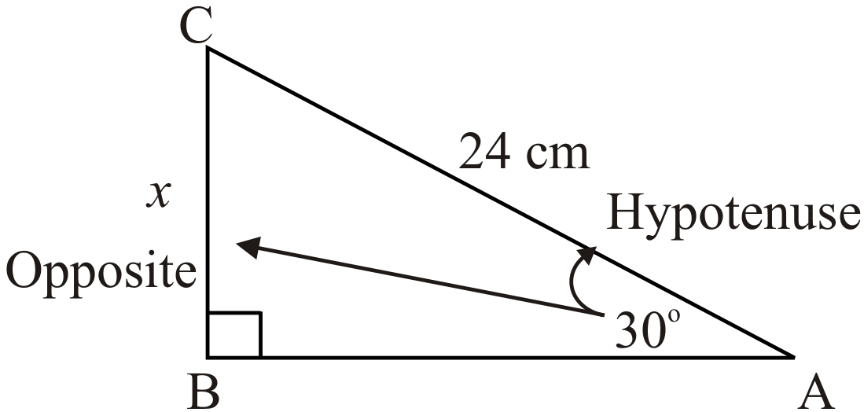
2. Decide whether to use sine, cosine, tangent, or the Pythagorean relationship to find. Solve for.
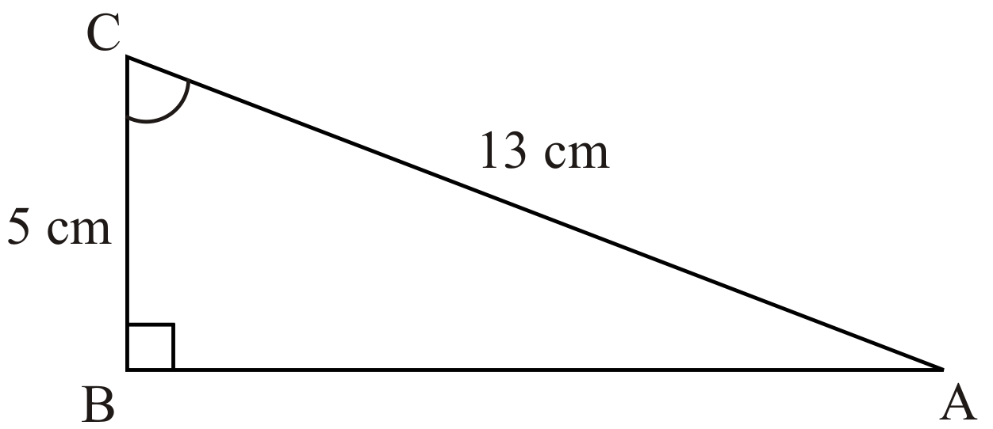
3. Decide whether to use sine, cosine, tangent, or the Pythagorean relationship to find b. Solve for b.
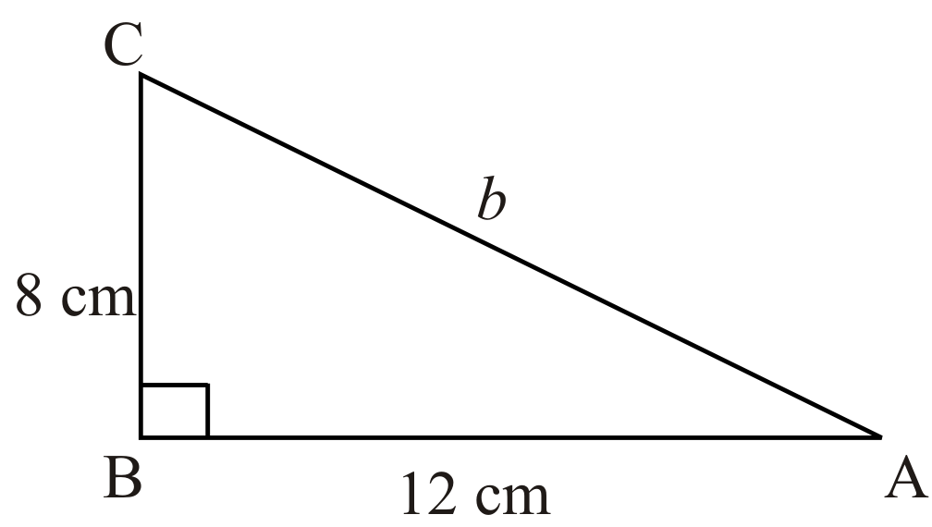
4. Decide whether to use sine, cosine, tangent, or the Pythagorean relationship to find x. Solve for x.
2.4.1: What’s My Triangle? (Continued)

5. Decide whether to use sine, cosine, tangent, or the Pythagorean relationship to find x. Solve for x.
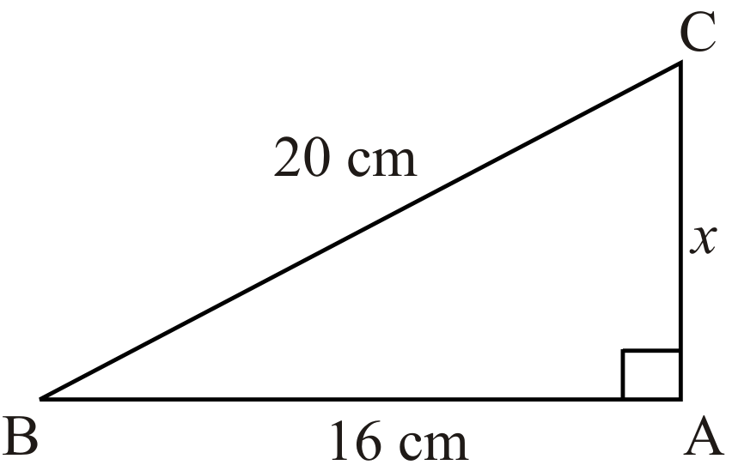
6. Decide whether to use sine, cosine, tangent, or the Pythagorean relationship to find ∠B. Solve for∠B.
7. Decide whether to use sine, cosine, tangent, or the Pythagorean relationship to find a. Solve for a.
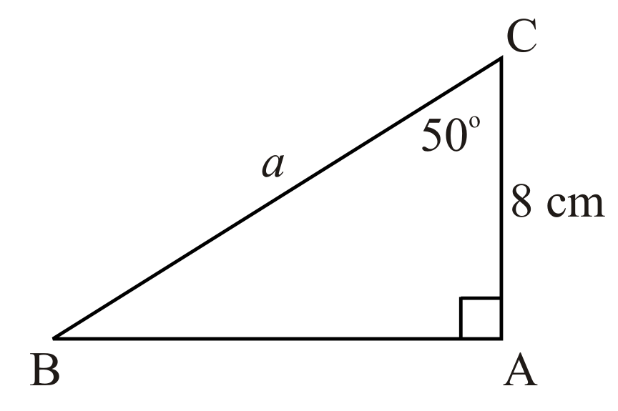
8. Decide whether to use sine, cosine, tangent, or Pythagorean relationship to find ∠C.
Solve for ∠C.
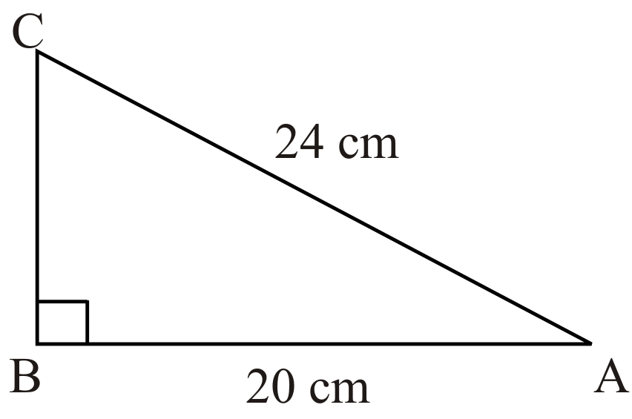

Unit 2 Day 5: Solving Right-Angled Triangles |  |  |  |  | Grade 10 Applied
Minds On: 10 Min. |  |  | Math Learning Goals  - Determine the measures of the sides and angles of right-angled triangles using the tangent trigonometric ratio and the Pythagorean relationship.  - Describe, through participation in an activity, the application of trigonometry in an occupation |  | Materials  - BLM 2.5.1  - BLM 2.5.2  - BLM 2.3.1 (from Day 3 - reference only)  - BLM 2.5.3  - computer lab for occupation research
Action: 55 Min.
Consolidate/
Debrief: 10 Min
Total = 75 Min.
Assessment
Opportunities
 | Minds On… | Pair / Share → Activity  Present pairs of students with BLM 2.5.1. Partner A will identify errors in solutions presented. Partner B will prepare a correct solution to the problems.  Curriculum Expectation/Oral Question/Anecdotal Note: Observe how students identify errors. Circulate and ask pairs to explain why they selected certain errors and what must be done to correct that error. |  |  | You will need to access student work completed previously on Day 3 for this activity.
 | Action! | Whole Class → Guided Instruction  Using questions 1–4, guide students to determine whether they would use the tangent ratio or the Pythagorean theorem to solve for the unknown side or indicated angle (BLM 2.5.2). [spend approx. 15 minutes on this activity]  Whole Class → Activity Instructions  Return to students’ work from Day 3, and the worksheet completed that day -BLM 2.3.1. Go over the occupation sheet and place emphasis on the section for Product. The remaining of the Action! time is allocated to students working on their project. Distribute BLM 2.5.3 with rubric for students.
 | Consolidate Debrief | Pairs → Reflection  In pairs, students will develop three examples of when to use the sine ratio, cosine ratio, and tangent ratio to solve a problem. Students can be challenged to make an example that has more than one solution to solve the example.
Application  Concept Practice  Skill Drill |  | Home Activity or Further Classroom Consolidation  Assign additional tangent questions for practice.  Students are also to complete their projects in preparation for future presentation.

2.5.1: Going the Wrong Way

There are two problems shown below. For each problem, the answer provided is incorrect. Partner A will identify the errors in the given solutions. Partner B will write a correct solution to the problem.
Partner A | Partner B
Solve for the missing side labelled x. | Solve for the missing side labelled x.
Solve for the missing side x.  x = 37.74 | Solve for the missing side x.

2.5.2: Tangent or Something else

1. Decide whether to the use tangent ratio or the Pythagorean relationship to find x. Solve for x.
2. Decide whether to use the tangent ratio or the Pythagorean relation to find ∠A. Solve for ∠A.
3. Decide whether to the use tangent ratio or the Pythagorean relationship to find x. Solve for x.
4. Decide whether to use the tangent ratio or the Pythagorean relation to find ∠C. Solve for ∠C.

2.5.3: Who Uses Trigonometry Research Assignment

You are to investigate someone who uses trigonometry in their professional lives. You will be responsible for submitting:
- a report
- a presentation

The Report
The report should describe what the profession is all about. Let us know what they do and what type of education is needed to enter that profession. The report should also include a description of how trigonometry is used by the professional in their work. What types of problems do they need trigonometry for? Include one example of a problem that could be solved using trigonometry from the field of work you are researching. A list of resources that you used must be included. These may be articles, books, websites, magazines, etc…

The Presentation
The presentation should provide a quick snapshot of your research. Include visuals (pictures, graphics, etc…) related to the profession. The presentation can be a poster, newspaper article created by you, a brochure that you have created, a skit, an electronic presentation, etc.

Your presentation should highlight:
- your chosen profession
- education needed (ie. college / university / workplace) and courses in high school
- what kind of problems the professional will need to use trigonometry to solve

Where do you get information?
The internet is a great place to start. You can do a search using the title at the top of the page. This will give you an idea of different professions and then you can investigate the specific one you pick. If you know someone who actually is in one of those professions, ask them!! The library is a great place to start and to get help on research.

Types of presentations
If you decide to present a skit it should be 5 minutes and could involve 3 people maximum. If you select to write a newspaper story it should 350-400 words, one graphic, proper newspaper format, and includes one interview quote. A presentation done as a brochure should be 4 or 6 sided and has 2 graphics. If you want to do an e-presentation, it should include 12-14 slides and make use of different transitions. A verbal presentation would be 2-3 minutes and have interaction with the audience. A visual poster would be bristle board size.

2.5.3: Who Uses Trigonometry Research Assignment (Continued)

A Word on Plagiarism
Copying and pasting something from the internet is plagiarism. You are submitting someone else's work as your own. If I suspect that your voice is not coming through when I read the paper, I will question you on your sources.

Evaluation Rubric
Your report will be evaluated using the following rubric.

Achievement  Category | Level R | Level 1 | Level 2 | Level 3 | Level 4
Knowledge/ Understanding | No evidence | Shows a limited understanding of the concepts | Shows some understanding of the concepts | Shows an understanding of the concepts | Shows a high degree of understanding of the concepts
Application | No evidence | Shows a limited connection between trigonometry and profession. | Shows some connection between trigonometry and profession. | Shows a connection between trigonometry and profession. | Shows more than one connection between trigonometry and profession.
Communication | No evidence | Report & poster shows limited clarity | Report & poster shows some clarity | Report & poster shows clarity | Report & poster shows a high degree of clarity

Comments:

Unit 2 Day 6: Math and the Outside World |  |  |  |  | Grade 10 Applied
Minds On: 5 Min. |  |  | Math Learning Goals  - Students will solve problems involving the measures of sides and angles in right triangles in real life applications (e.g., in surveying, in navigation, in determining the height of an inaccessible object around the school), using the primary trigonometric ratios and the Pythagorean theorem |  | Materials  - BLM 2.6.1  - glue sticks, cardboard pieces, scissors, string, masking tape, straws, paper clips / washers / pennies, fibre glass measuring tapes  - BLM 2.6.2  - BLM 2.6.3
Action: 60 Min.
Consolidate/
Debrief: 10 Min
Total = 75 Min.
Assessment
Opportunities
 | Minds On… | Pair / Share → Brainstorm  Present pairs of students with the problem of what measurements would they need in order to calculate the height of an object like a tree or utility pole? Students should prepare a diagram that shows the measurements they would need. Ask students if it is possible to make all the measurements they require?  Curriculum Expectation/Oral Question/Anecdotal Note: Observe how students select measurements. Circulate and ask pairs to explain how they could collect their data. |  |  | Some students may indicate they need the length of the hypotenuse. Discuss whether this measurement is reasonable (ie. if you can get to the top of the object to measure the hypotenuse, then why not just measure the height directly?)  If more time is desired for the activity, clinometers could be pre-made.  A penny can be taped to the string in place of using a washer or paper clip. Larger straws make for easier lines of sight. (McDonald’s drinking straws are a good size)  Teacher may want to collect worksheets to assess / evaluate mathematical processes
 | Action! | Groups of 3 → Investigation  Hand out a copy of BLM 2.6.1 to each group. Provide materials needed for each group to construct one clinometer. Each group will also require a fibre glass measuring tape for measuring distances.  Distribute BLM 2.6.2. Assign 3 objects for each group to go and measure. Each group does not need to have 3 identical objects. Some overlap in objects will be helpful for discussion / debrief.
 | Consolidate Debrief | Whole Group → Reflection  Distribute BLM 2.6.3. Give students opportunity to read over and discuss question 1 in their groups. Ask each group to report whether they think the question can be solved and to explain why or why not?  Assign question #2 to complete individually.
Application  Concept Practice  Skill Drill |  | Home Activity or Further Classroom Consolidation  Assign additional practice questions for using the tangent ratio.

2.6.1: Constructing a Clinometer

A clinometer is used to find the angle of elevation of an object.
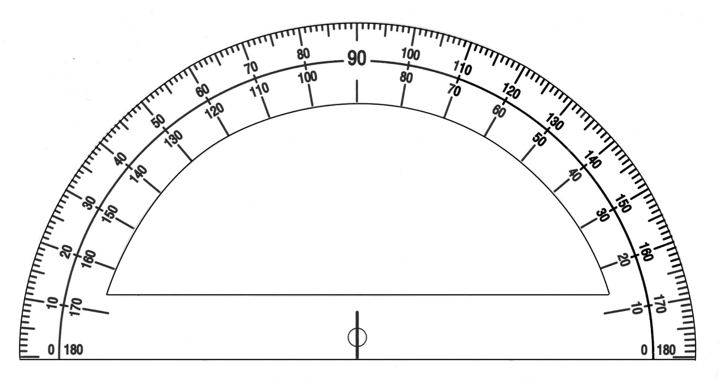

------------------------------------------------------------------------------------------------------------

Read all directions carefully before you begin

- Cut along the dotted line above, and glue the protractor onto a piece of cardboard. Carefully cut around the edge of the protractor.
- Take a 20 cm piece of string, and tie a washer or paperclip to one end. The other end should be taped to the flat edge of the protractor so that the end touches the vertical line in the center, and the string can swing freely. This can best be done by taping the string to the back of the protractor and wrapping it around the bottom.
- Glue a straw to the flat edge of the clinometer. The finished product should look like figure 1 below

You can now use your clinometer. To find an angle of elevation, look through the straw to line up the top of an object. The string hanging down will then be touching the angle of elevation. Note: The angle you measure will always be less than 90º when you are reading the clinometer.
2.6.2: Applications of Trigonometry Assignment

Introduction
How would you find the height of a tree? You could climb to the top to measure it, but that would not be either safe or practical. How can we measure the height of clouds, airplanes or other highly inaccessible objects? Airports measure the clouds for pilots to let them know at what altitude they should fly. In this activity you will measure the heights of various objects using a single clinometer and trigonometric ratios.

You will measure the following heights:
- ___________________________________

- ___________________________________
- ___________________________________

You must hand in the following details:
- Show a table of data
- Show ALL calculations
- Table of results
- Sources of error

Building Clinometer
First you will need to make clinometer. You will be using the protractor template using the instructions on handout 2.6.1 given to you by your teacher. Glue the template onto a piece of cardboard.
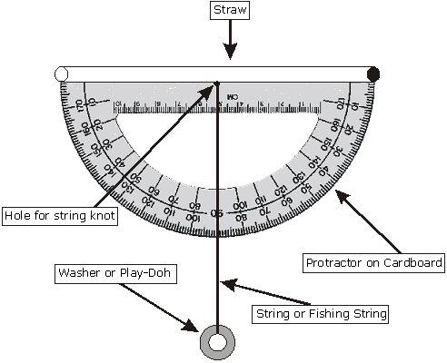

2.6.2: Applications of Trigonometry Assignment (Continued)

Measuring Distances
Use a tape measure to find an appropriate distance back from the object you are finding the height of. Hold the clinometer level along the horizon line and adjust the angle of the straw to sight the top of the object through the straw.

A

METHOD for finding inaccessible heights

Object  Name | Height of person’s eyes from ground (m) | Angle of  Elevation  (A) | Distance from  Base (m) | Height of Object  (Show work in box)

2.6.3: Applications of Trigonometry Assignment

Analysis
- If you were to measure the height of a light sticking out from a post could you use today’s method? Explain why or why not.
LIGHT

- Darla is standing 15 m from the base of a building and using a clinometer she measures the angle of elevation to be 37°. If her eyes are 1.65 m above ground level, find the height of the building.

Unit 2 Day 7: Trigonometric Applications |  |  |  |  | Grade 10 Applied
Minds On: 10 Min. |  |  | Math Learning Goals  - Solve problems involving the measures of sides and angles in surveying and navigation problems. |  | Materials  BLM 2.7.1, 2.7.2, 2.7.3  Sticky notes  Chart paper
Action: 40 Min.
Consolidate/
Debrief: 25 Min
Total = 75 Min.
Assessment
Opportunities
 | Minds On… | Think, Pair, Share → Timed Retell  Students individually write answers on sticky notes to the following questions:  - How can you measure an inaccessible object using trigonometry?  - What can trigonometry be used for in the real world?  In pairs, each person shares their answer to one question and then post the sticky notes on a bulletin board or chart paper.  Math Process/Reflecting/Mental Note: Observe how students demonstrate understanding of solving triangles and measuring inaccessible objects.  Differentiated Instruction →Research/Brainstorm: Pairs of students work together on a computer to research applications of trigonometry on the internet. Ask: What can trigonometry be used for in the real world? Each pair should determine at least four applications. Write the findings on sticky notes and post them for the class to discuss. |  |  | Students should recall the clinometer activity.  See Mathematical Processes in Leading Math Success Library  Recommend having a different problem from 2.7.1 at each station so students focus on one problem at a time.  At this stage, students should not attempt to solve the problems.
 | Action! | Groups of 3 → Carousel  Students examine various applications shown in BLM 2.7.1. In their groups, answer the questions:  - Draw a diagram to represent the problem.  - What is given?  - What is required?  - What tools can be used to solve the problem?  Use BLM 2.7.2 to summarize their findings at each carousel station.  Math Process/Connecting/Checklist: Verify that students can correctly identify the trigonometric ratio that is used to solve the problems.
 | Consolidate Debrief | Whole Class → Guided Instruction  Review students findings from the carousel. Guide students through the solution to one or two of the carousel problems.  Students will complete the remaining problems in their groups.
Concept Practice  Differentiated |  | Home Activity or Further Classroom Consolidation  Complete additional practice questions on BLM 2.7.3.  Research an application of trigonometry and construct a problem that could be solved. Exchange problems.

2.7.1 Applying Trigonometry

Use BLM 2.7.2 to organize your solution steps.
Then, solve the application questions. Find angles to the nearest degree and distances to the nearest tenth of a unit.

1. A ladder is leaning against a building and makes an angle of 62° with level ground. If the distance from the foot of the ladder to the building is 4 feet, find, to the nearest foot, how far up the building the ladder will reach.  4 ft  55°  ? | 2. The Dodgers Communication Company must run a telephone line between two poles at opposite ends of a lake as shown below. The length and width of the lake is 75 feet and 30 feet respectively.  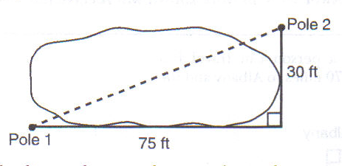  What is the distance between the two poles, to the nearest foot?
3. A ship on the ocean surface detects a sunken ship on the ocean floor at an angle of depression of 50° . The distance between the ship on the surface and the sunken ship on the ocean floor is 200 metres. If the ocean floor is level in this  area, how far above the ocean floor, to the nearest metre, is the ship on the surface? | 4. Draw and label a diagram of the path of an airplane climbing at an angle of 11° with the ground. Find, to the nearest foot, the ground distance the airplane has traveled when it has attained an altitude of 400 feet.

2.7.2: Trigonometry -- Getting it together

Use the following chart to analyze the applications given in the problems on BLM 2.7.1.

What is given? –What angle and side measurements are stated in the problem?
What is required? -- What angle and side measurements do you need to find?
What tools can be used to solve the problem? – Name a trigonometric ratio.

Application  (include a diagram) | What is Given? | What is required? | What tools can be used to solve the problem? | Solution

2.7.3: Applying Trigonometry

Solve the application questions. Draw a diagram where necessary.
Find angles to the nearest degree and distances to the nearest tenth of a unit.

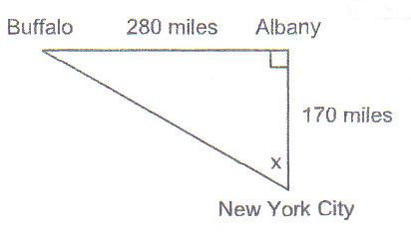  - If an engineer wants to design a highway to connect New York City directly to Buffalo, at what angle, x, would she need to build the highway? Find the angle to the nearest degree.  To the nearest mile, how many miles would be saved by travelling directly from New York City to Buffalo rather than by travelling first to Albany and then to Buffalo? | - In order to safely land, the angle that a plane approaches the runway should be no more than 10°. A plane is approaching Pearson airport to land. It is at an altitude of 850 m. It is a horizontal distance of 5 km from the start of the runway. Is it safe for the plane to land?
- An 8 m long ramp reaches up a vertical height of 1m. What angle does the ramp make with the ground? | - A tree casts a shadow 42 m long when the sun’s rays are at an angle of 38° to the ground. How tall is the tree?

Unit 2 Day 8: Who Uses Trigonometry? |  |  |  |  | Grade 10 Applied
Minds On: 10 Min. |  |  | Math Learning Goals  - Make a presentation to the class on careers that involve trigonometry. |  | Materials  - BLM 2.8.1  - Stickers or stars to assess the projects
Action: 55 Min.
Consolidate/
Debrief: 10 Min
Total = 75 Min.
Assessment
Opportunities
 | Minds On… | Whole Class → Activity Instruction  Students will set up their project presentations around the room in designated areas.  Review the instructions and expectations for the period.  As a class, determine Criteria for a ‘great project’ (3 Stars), a ‘good project’ (2 Stars) and a ‘satisfactory project’ (1 Star). Students will use this criteria to give a peer assessment projects at the end of the period. |  |  | Set up the room to facilitate a gallery walk of the projects leaving room for groups to gather to discuss the projects they have seen.  Suggest a random selection of presentations.  Provide two copies of the project summary (2.8.1) for each student  Write the criteria for peer assessment on the board, overhead or chart paper.
 | Action! | Groups of 4 → Jigsaw  Teacher organizes students into groups of 4. Each group member visits two project presentations that are not their own. Students will use BLM 2.8.1 to collect information to bring back to their group. Suggest that students take approximately 3-5 minutes at each presentation.  Groups of 4 → Reporting/Reflection  Students return to their home groups to share findings.  Discuss the similarities and differences between the different careers.  As a group, rank the careers (not the projects) with respect to:  - Interest (Which is the most interesting career?)  - Amount of education required (Which career appears to be the most attainable?)  Learning Skills/Teamwork/Mental Note Observe students interactions as they collaborate to reach conclusions about various careers involving trigonometry
 | Consolidate Debrief | Students complete a Gallery Walk of all the project presentations. Assign projects a ranking of 1, 2, or 3 Stars based on the criteria determined at the beginning of the class.
Concept Practice  Reflection |  | Home Activity or Further Classroom Consolidation  Assign additional trigonometry practice questions for review.  Journal Entry: A career that uses trigonometry that I could do is… Explain why.

2.8.1: Who Uses Trigonometry? Organizer

Visit two other project presentations and collect information to return to your home groups.

Title of Project: |  | Presented by/Author:
The type of education they need is… | They use trigonometry in their job by…  (Include a description, example, or diagram) |  | The most interesting thing is…
One thing I’ll remember is… | I’m still wondering about… |  | Someone who I think would be good at this job is…

